Centercomb VST
Manual for Windows by aquanode (2026)


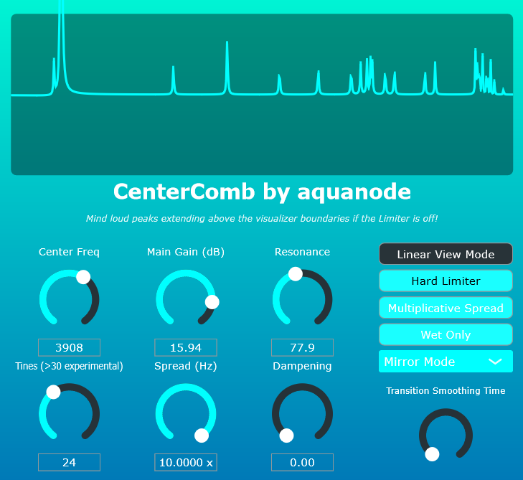
WARNING: Using both the multiplicative spread AND mirror or wrap mode SIMULTANEOUSLY is experimental and will very likely produce loud volume spikes – especially when you add tines. I recommend only using one of these modes at a time, then everything should be fine.
Personal / Copyright Message: This plugin is a passion project for the community. The compiled plugin Is free, and the source code open. Keeping things simple & fair, the rules are as follows:
- Open Source: The source code is available for free, it comes together with the plugin when you download it. To compile from source, you need JUCE and Visual Code. You are welcome to modify the code and use it however you like, but don’t sell it for money unaltered. Sharing everything for free is totally fine, and encouraged! If you build the code into your own projects (i.e. alter it to a certain amount that it becomes your own thing), then you can sell it as your own thing of course.
- Official Support: If you don’t want to compile the plugin yourself, you can download it. The only official place to purchase the VST3 file directly is aquanode.gumroad.com for a recommended amount of €3, but feel free to type in 0. Buying there ensures you have the original files and my sincere thanks for your support.
- Sharing is Caring: I don’t track licenses, so you may share the VST with your friends, as long as you do not charge money for it. If you see this plugin being sold anywhere else, it’s a scam.
- No Warranty: I am not responsible for any damages, and when you download the plugin from a third-party website, for malware or viruses. Use such versions at your own risk.
Thank you for your interest in my 3rd VST plugin, which I built with JUCE/Visual Code C++.

“CenterComb” is, as the name suggests, a flanger-inspired comb filter effect built from a bank of parallel bell peak filters distributed symmetrically around a central frequency.

It is a VST equivalent of an earlier bandpass filter effect I created in FL Studio’s Patcher for example, that are free to download on aquanode.gumroad.com.

Features

- NEW in version 1.1: Smoothing for smooth transitions between filter states when you move knobs. This makes sometimes very nice bubble / liquid sounds.
- NEW in version 1.1: Mirror and Wrap Modes. If Mirror mode is active, frequencies that would be outside the audible range will be mirrored at 20 and 22000 Hertz respectively. This is kind of an "aliasing" mode and can produce nice tones. The same goes for the Wrapping mode: If it is active, frequencies that go out of one boundary will reappear at the other one. Please note that using BOTH Multiplicative and either Mirror or Wrap Mode at the same time is experimental, as for many tines frequencies quickly become too large for floating point accuracies. I implemented some safety measures on the fly, they are not indended to be mathematically correct.
- Up to 129 simultaneously active bell filters, each ranging from −24 dB to +24 dB.

- Linear and multiplicative bell peak distribution modes, allowing filter spacing by fixed Hertz values or exponential frequency ratios.

- A real-time graphical frequency response display, also independently switchable between linear and logarithmic frequency visualization modes.

- Center frequency anchoring, with symmetrical bell filter placement above and below the selected frequency.

- Resonance (Q) control for shaping filter sharpness from smooth tonal curves to extreme spectral peaks.

- Spectral dampening control to progressively attenuate outer filter tines for smoother or more aggressive responses.

- Wet-only output mode for pure spectral processing without dry signal.

- Optional hard limiter to control extreme resonant peaks during aggressive sound design.

- Designed for flanging, resonator effects, harmonic sculpting, and experimental sound design.

How to install
Next to the .vst3 and this pdf, you will find 4 files with endings .h and .cpp in this folder. These make up the complete source code for JUCE, so you can compile and remake the whole effect plugin yourself if you like. Otherwise, you don’t need them.

As I do not own a Mac, only PC / Windows is supported. The plugin was tested on Windows 11 22H2, FL Studio 25, Ableton Live 11, and using Tracktion’s pluginval.
  - Download the zip file and extract it (you did this already).
  - Copy the .vst3 file into your system's VST3 folder. Usually, this is:
C:\Program Files\Common Files\VST3
  - Rescan your DAW’s plugin library (FL Studio, Ableton Live, etc.). The plugin should appear under the "Effects" or "Filter" category.
  - Add it to a mixer track, to which sound is routed.

explanations of the controls

Sliders

Center Freq
Sets the central anchor frequency of the comb. All additional filter “tines” are placed symmetrically around this frequency.

Tines
Controls how many bell filters are added on each side of the center frequency.
Higher values create denser, more complex comb patterns (up to 64 mirrored filters, giving you up to 1 + 2 x 64 = 129 total filters).

Main Gain (dB)
Sets the gain applied to each bell filter before damping is applied. Higher values result in more pronounced peaks and resonances.

Spread
Controls the distance between tines:
- Linear mode (Hz): Tines are spaced evenly in Hertz.
- Multiplicative mode (Ratio): Each tine is spaced by a frequency ratio, creating musically exponential spacing.
The spread mode can be toggled via the Spread Mode button, see below.

Resonance (Q)
Controls the sharpness of each bell filter.
Low values create smooth, wide curves; high values produce sharp, resonant peaks.

Dampening
Gradually reduces the gain of tines as they move farther from the center frequency. This helps tame extreme peaks and creates more natural spectral falloff.

Toggles

Linear View
Switches the response visualizer between:
- Linear frequency display
- Logarithmic frequency display
(This does not affect audio — only visualization.)

Spread Mode
Toggles between:
- Linear (Hz) spacing
- Multiplicative (ratio-based) spacing

Wet Only
Outputs only the processed signal, removing the dry input entirely.

Hard Limiter
Engages a safety limiter to prevent extreme resonant peaks from clipping.
Disabling this allows for aggressive sound design — use with caution.
Mode Selector (New in Version 1.1)
Regular: Frequencies extending outside of 20 to 22000 Hz are cut off.
Mirror Mode: Frequencies extending the range will get mirrored at the ends.
Wrap Mode: Frequencies extending the range will appear at the other end.
Smoothing Knob
If you change a knob value such as spread, it will either be instantly if smoothing is turned all the way to 0, or will take up to a few seconds until the new state is reached.
Many thanks to Google for their Gemini AI that was indispensable for me to grasp how JUCE and C++ programming even works. It was a real time-saver, as I did not need to become an expert in all the details. The downside to that is of course that I’d still not be able to program a plugin without its help.
Fonts used in this Documentation: Aquatico, Bahnschrift, Conthrax.

